### User Training



Updated April 2013

*This document is confidential and is intended solely for the use and information of the client to whom it is addressed.*

**Transit Economic Requirements Model**

## Overview

What is TERM?

 FTA’s Capital Needs Analysis Tool

– Used to assess the current physical condition and future investment needs of the nation’s transit assets / operators

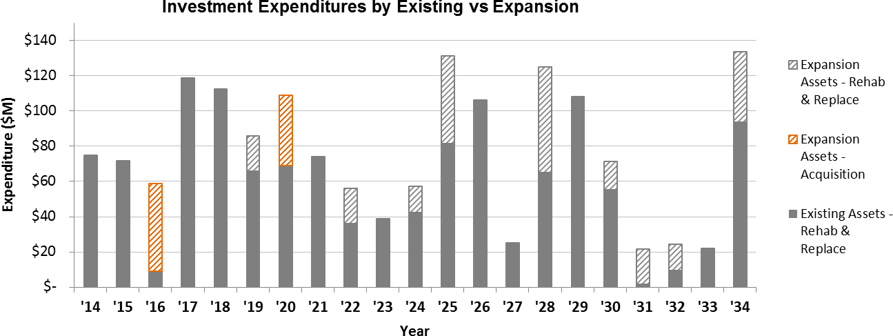

What is TERM?

 Transit Economic Requirements Model



 National level analysis of:

* State of Good Repair backlog
* Asset conditions
* 20-year projection of reinvestment needs
* Impact of variations in funding

 Approximately $5 million in development since 1995



What is TERM?

 Determines level of investment required to:

* Maintain condition/performance
* Improve condition/performance

 Assesses impact of constrained investment on future conditions / performance

 Cost effectiveness of proposed investments (benefit–cost analyses)

 Results reported in the transit sections of the “Status of the Nation’s Highways, Bridges, and Transit: Conditions and Performance” (C&P)

# In Addition to the C&P Report, TERM is Used to Develop Related Reports

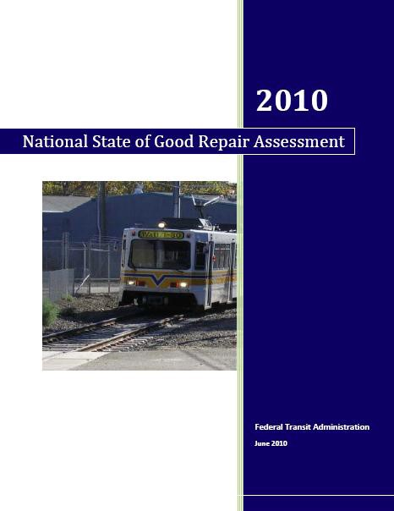

The ***National Surface Transportation Commission*** examined the condition and future needs of the nation's surface

transportation system

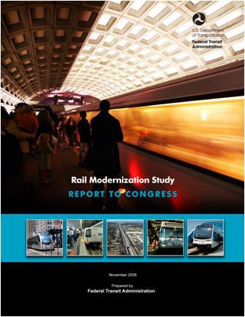

The ***Rail Modernization Study*** assessed the investment backlog and capital reinvestment needs of the nine largest rail operators

The ***National State of Good Repair*** assessed the investment backlog and capital reinvestment needs of the transit industry

# Capital Needs Assessments Include all Asset Types

Vehicle

Fleets

rail, buses, vans, non revenue vehicles

Equipment & Furnishings

maintenance equipment, computers, elevators, escalators

New Technologies

AVL/CAD/APC, real

time info

Systems

electrification, communications, control systems

Stations & Facilities



**Federal Transit Administration**

administration, maintenance, passenger facilities

# Transit Asset Database

Transportation

Networks

guideway, track, dedicated lanes

# Data on the Condition of Some Asset Types have been Obtained Through Inspections

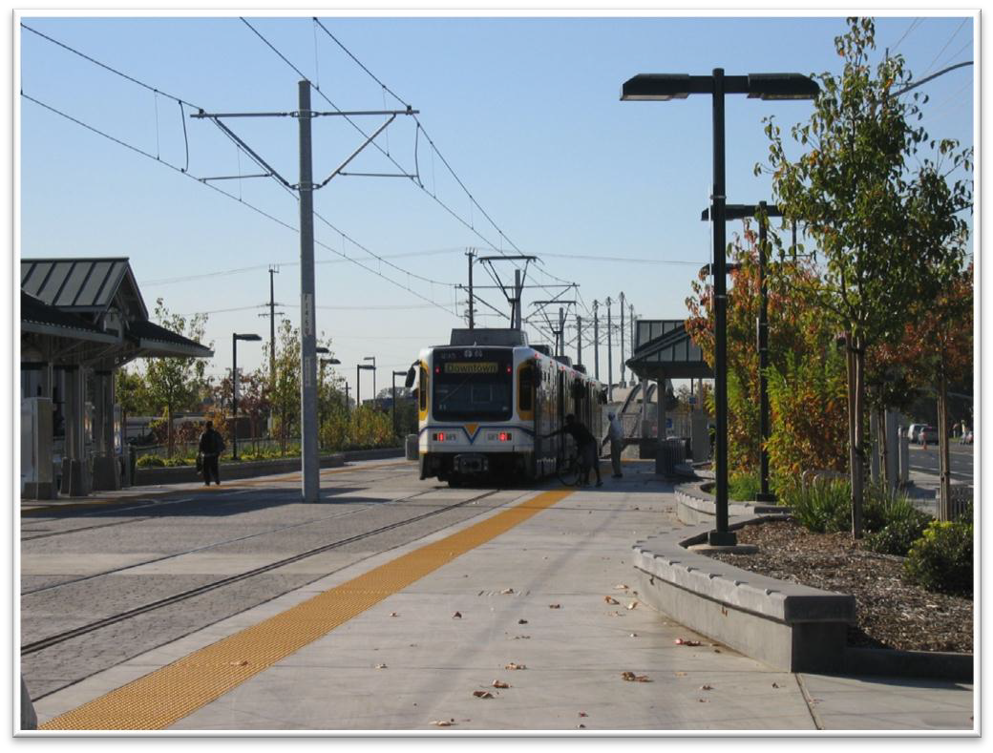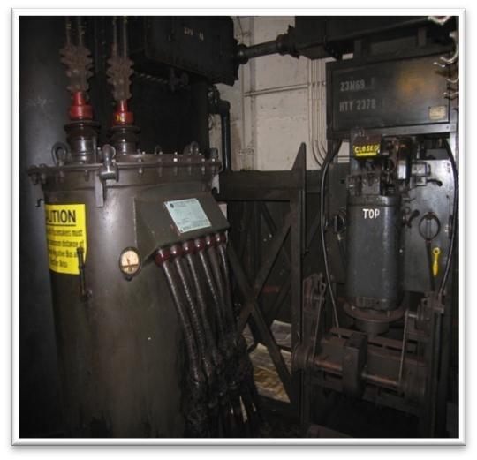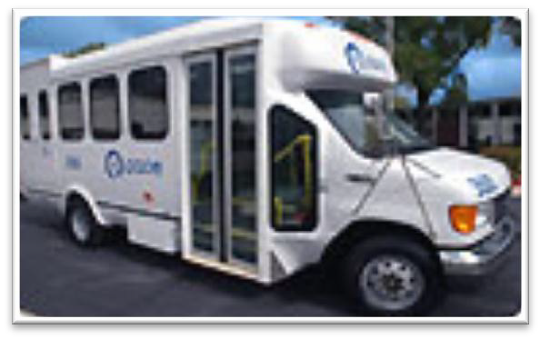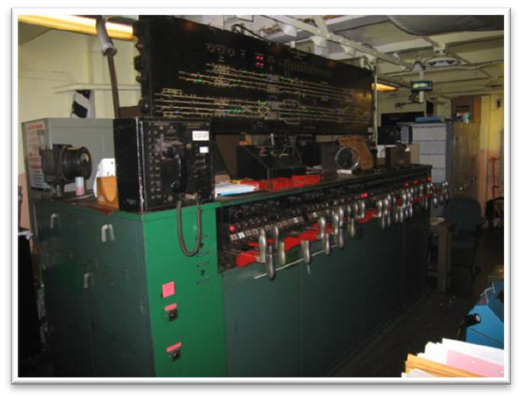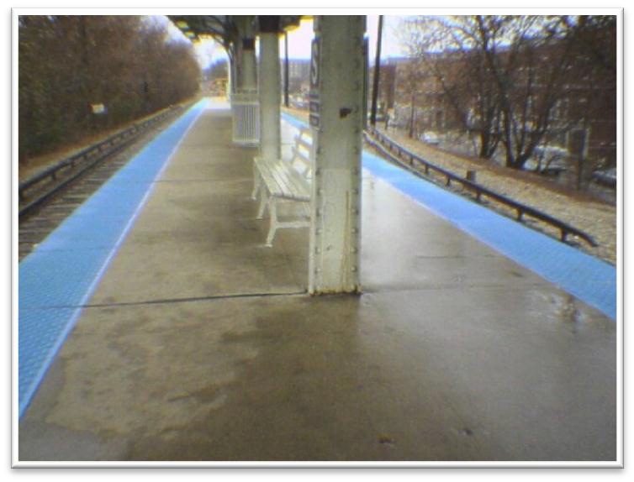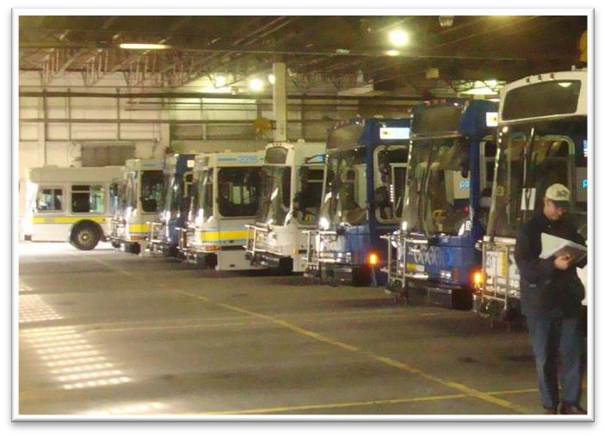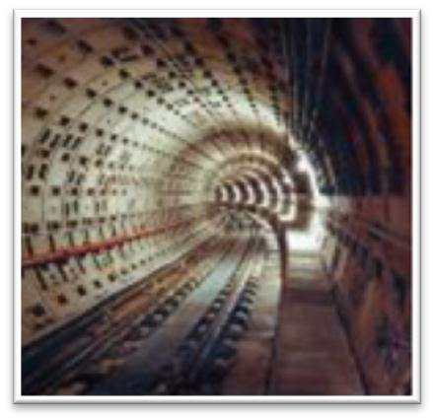

The Transit Economic Requirements Model (TERM) was developed to answer the question, “Where will we be in 20 years?”

The answer depends on three primary factors. The following questions are open ended but are eventually translated into relational tables that allow TERM to simulate a 20-year scenario.



**$**



What does your inventory look like today?

How much can you spend in each year?

What is most important for you? Safety? Reliability?

Something else?

# Do we know our inventory?

Knowing your inventory is the first step to being able to analyze the true cost ownership.

* + What types of assets do we have?
  + How many assets do we have of each kind and how big are they?
  + What is the age of each asset? And is the condition appropriate for its age?
  + How often must an asset be rehabilitated and at what cost?
  + What is the cost to replace one unit of each asset type?
  + What assets can never be replaced?
  + Do we have redundant or non-essential inventory?



# How much can we spend?

The future condition of your portfolio depends on a complex combination of capital replacement programs, operations, maintenance & sustainment practices, worker training, investments in tools, and strategic planning. All of these require funding. Future funding is rarely known but typical scenarios include the following:

* Continue to spend some historical flat amount each year.
* Increased flat funding each year
* Increased short-term funding to reduce deferred maintenance followed by a historical flat amount.
* Unlimited funding
* No funding

**$**

# What are our priorities?

Every asset in your inventory contributes to meet your organization’s goals and mission objectives. If they don’t, you should probably decommission them. When funds are constrained, budget planners must consider where to spend the available money first. Criteria that is most often considered for a transit planner include the following:

* + Safety & Security
  + Reliability
  + Operations & Maintenance Impact
  + Customer Experience
  + Asset Condition



# TERM Simulates how you Invest in your Assets

Once the current inventory, spending constraints, prioritization criteria, and a few other economic assumptions are provided, TERM simulates up to 30 years of aging, wear & tear, rehabilitation, maintenance, and replacement for a collection of assets.

Asset Conditions Forecast

State of Good Repair Needs Forecast ($)

**20-Year Simulation**

Execute Annual Spend Plan

Evaluate Impact

of Spend Plan

Simulate Annual Spend Prioritization

E luate State

Inventory in

Yearn

**Model Run:**

**Needs Forecast**

Listing of Current Asset Inventory (Track, Structures, Systems, Facilities, Vehicles, Stations)

**Asset Inventory**

Rehabilitate/replace all assets at the end of their Estimated Design Lives

**Establish Investment Policies**

# TERM is an MS Access-based tool designed for use by a novice

The analyst controls the simulation by using the following modules:

* **Inventory Publisher**: Transferring inventory data from MS Excel to TERM
* **Prioritization Settings**: Assign priority weights to each of five criteria and score each asset type on those five criteria
* **Expenditure Constraints**: Specify the maximum annual funding available to the simulator
* **Backlog Target Seek**: Optimize funding to achieve a specific reduction in backlog
* **Inventory Management:** Add, delete, or modify the inventory details
* **Expansion Analysis:** Review the impact of adding new capacity on annual expenditure needs and long-term backlog growth/decline
* **Life Cycle Cost**: Edit assumptions regarding number and cost of interval rehabilitations, unit replacement cost, and useful life by asset type
* **Inflation Module**: Specify how costs should be escalated over time and how results are displayed

# Inventory Publisher

TERM-Lite is developed in MS Access. Users that are comfortable using Access may choose to become familiar with the tables and manage the data directly in the model.

However, FTA has developed an MS Excel-based Inventory Publisher which helps format data to conform to TERM’s business rules.

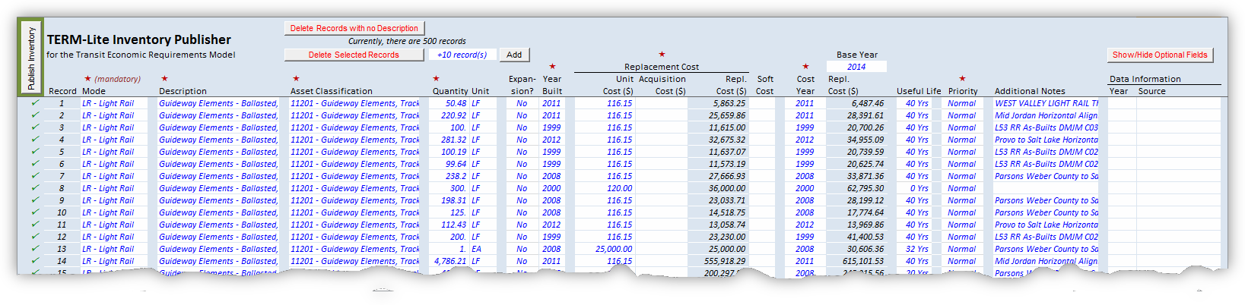

# Prioritization Settings

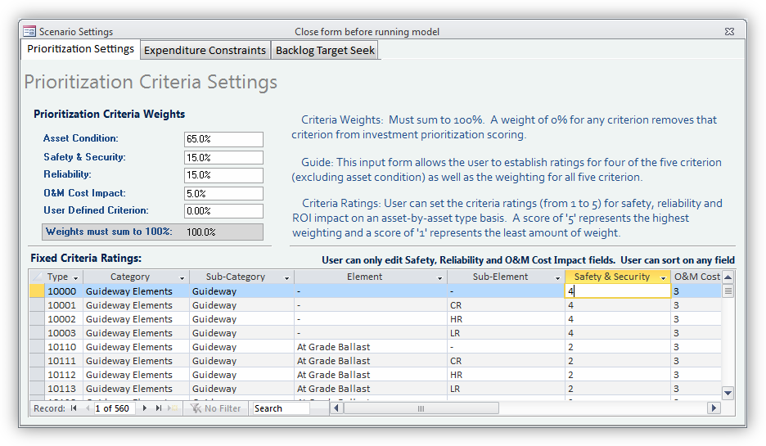TERM-Lite simulates the long- term impact of *constrained* funding scenarios using a robust prioritization algorithm. The model considered five dimensions of priority: Asset Condition, Safety & Security, Reliability, O&M Cost Impact, and one User Defined criteria. The User is in control of how each asset type scores against other asset types. The User also determines how each criteria is weighted against other criteria.

# Expenditure Constraints

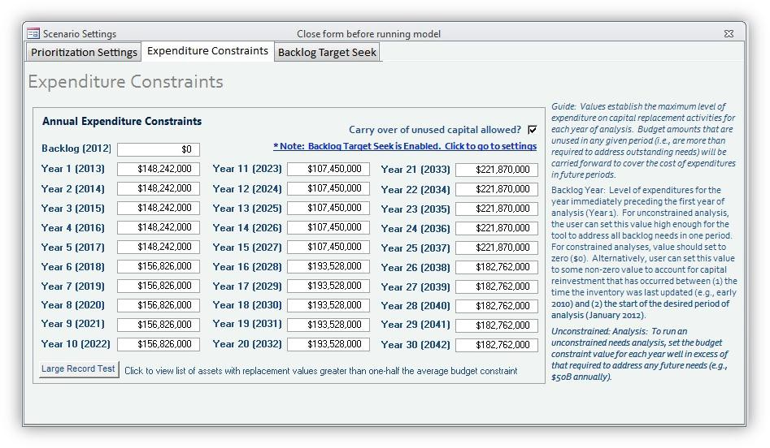The User controls the amount of funding that is available for each of the years of analysis.

The User can specify whether unspent funds are carried over to future year or returned to the funding authority based on that agency's unique circumstances.

A built-in ‘Large Record Test’ will help the User evaluate of the inventory is structured optimally for TERM-Lite analysis.

# Backlog Target Seek

In contract to using the Expenditure Constraints module, the User can also specify a performance outcome by reducing existing backlog to a specific level within a desired period of time. TERM-Lite calculates the annual funding required to achieve this objective.

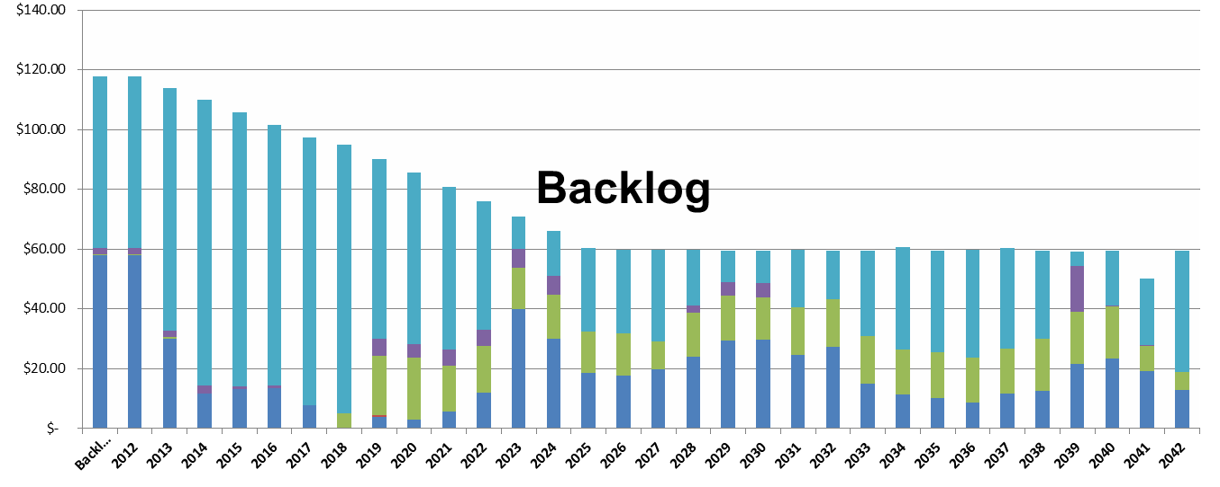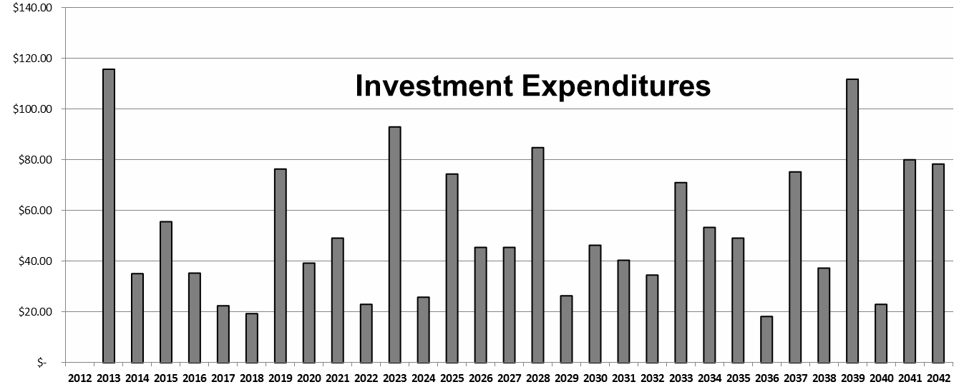

# Inventory Management

The User can review, perform quality assurance, edit, delete, or modify individual asset records.

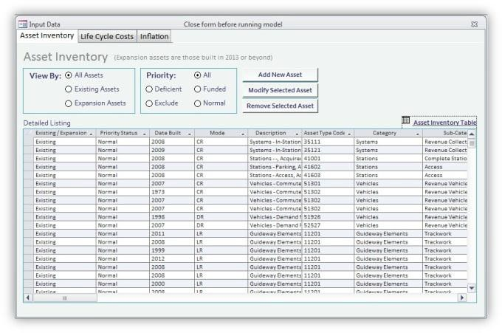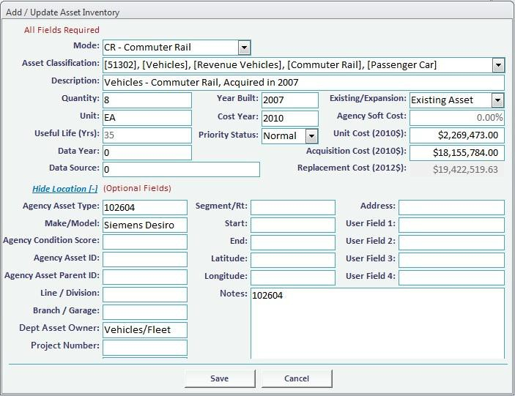

Each record can include a unique cost basis, quantity, useful life, and age.

Each asset can be tagged as one be of four levels of “overriding” priority (Funded, Deficient, Normal, or Exclude).

In addition, twenty (20) fields are available to track metadata that is important to the agency.

# Expansion Analysis

The User can choose to include planned or prospective capital improvements in the analysis. This “what-if” scenario analysis allows a thorough review of the impacts of such improvements on spending needs and, when funding is constrained, on overall portfolio performance (as measured by average age, and condition).

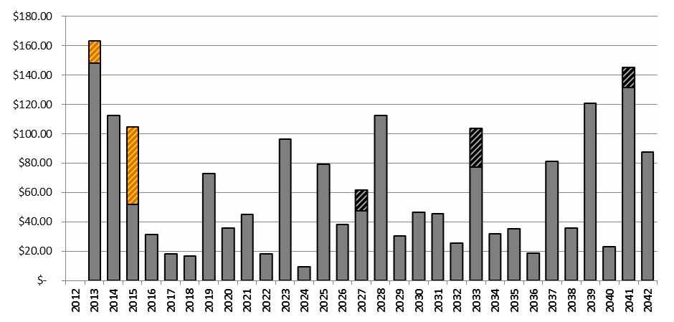

Expansion Rehab/ Costs Replacement Costs

# Life Cycle Cost and Inflation

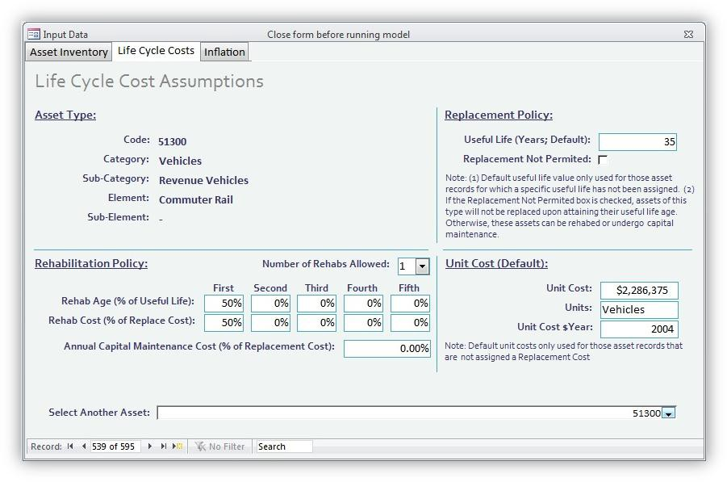Users can customize the rehab and replacement cost assumptions for each asset type. This customization can include up to five (5) intermediate rehabs stated as a percentage of the replacement cost.

Assets that are typically maintained for an indefinite period (tunnels or historic assets), an annual capital cost can be defined to allow for regular investments in rehab.

TERM-Lite analysis can be run using any desired assumed inflation rate.

**Billions of $YOE**

2013

2014

2015

2016

2017

2018

2019

2020

2021

2022

2023

2024

2025

2026

2027

2028

2029

2030

2031

2032

2033

2034

2035

2036

2037

2038

2039

2040

SGRB

2013

2014

2015

2016

2017

2018

2019

2020

2021

2022

2023

2024

2025

2026

2027

2028

2029

2030

2031

2032

2033

2034

2035

2036

2037

2038

2039

2040

SGRB

2013

2014

2015

2016

2017

2018

2019

2020

2021

2022

2023

2024

2025

2026

2027

2028

2029

2030

2031

2032

2033

2034

2035

2036

2037

2038

2039

2040

**Percent of**

# TERM provides analysis charts and reports that describe the outcome of each scenario

Reports help the analyst visualize the resulting condition and service performance of the asset inventory based on the input settings. Comparing multiple scenarios side by side help build a business case to support “right funding” of the portfolio

**vestment Expenditures by Category**

Systems

**placement ($1.3B)** Facilities

Stations

Guideway Elements Vehicles

**centof Assets Over Age**

**Assets in Mar**

**(Excludes**

**30%**

All Assets

**25%**

**ue**

Replaceable Assets **l**

**a V**

Non-Replaceable Assets **nt**

**e 20%**

**m e c a**

**pl**

**R 15%**

**e**

**l a**

**ot T**



**SGR Backlog by Category**

$25.0

**Per**

35%

$20.0

Systems

30%

**In**

$15.0

Facilities

$7.0

25%

$10.0

$6.0

20%

**ginal or Poor Condition**

Stations **Unreplaceable Assets)**

Guideway Elements Vehicles

$5.0

$5.0

15%

$4.0

**Average AnnualNormalRe**

10%

$0.0

$3.0

**Marginal**

**Poor**

5%

$2.0

**10%**

0%

$1.0

**5%**

$0.0

**0%**

**Weighted Average Asset Age**

**$Billions**

Facilities

Stations

Guideway Elements Vehicles

$3.0

$2.0

**Average Annual Normal Replacement ($1.3B)**

$4.0

**Billions of $YOE**

2013

2014

2015

2016

2017

2018

2019

2020

2021

2022

2023

2024

2025

2026

2027

2028

2029

2030

2031

2032

2033

2034

2035

2036

2037

2038

2039

2040

# TERM provides analysis charts and reports that describe the outcome of each scenario



**Investment Expenditures by Category**

$7.0

$6.0

$5.0

Systems

$1.0

$0.0

Systems

Facilities Stations

Guideway Elements

Vehicles

$15.0

$10.0

$20.0

**$Billions**

SGRB

2013

2014

2015

2016

2017

2018

2019

2020

2021

2022

2023

2024

2025

2026

2027

2028

2029

2030

2031

2032

2033

2034

2035

2036

2037

2038

2039

2040

TERM provides analysis charts and reports that describe the outcome of each scenario



**SGR Backlog by Category**

$25.0

$5.0

$0.0

TERM provides analysis charts and reports that describe the outcome of each scenario

35%

**Percent of Assets Over Age**

30%

25%

**Weighted Average Asset Age**

20%

15%

All Assets Replaceable Assets

Non-Replaceable Assets



10%

5%

0%

SGRB

2013

2014

2015

2016

2017

2018

2019

2020

2021

2022

2023

2024

2025

2026

2027

2028

2029

2030

2031

2032

2033

2034

2035

2036

2037

2038

2039

2040

# TERM provides analysis charts and reports that describe the outcome of each scenario

**30%**

### Assets in Marginal or Poor Condition

**(Excludes Unreplaceable Assets)**



**25%**

**Percent of Total Replacement Value**

**20%**

**15%**

**Marginal Poor**

**10%**

**5%**

**0%**

# Questions?

**Rick Laver** CH2M Hill 703-946-5065

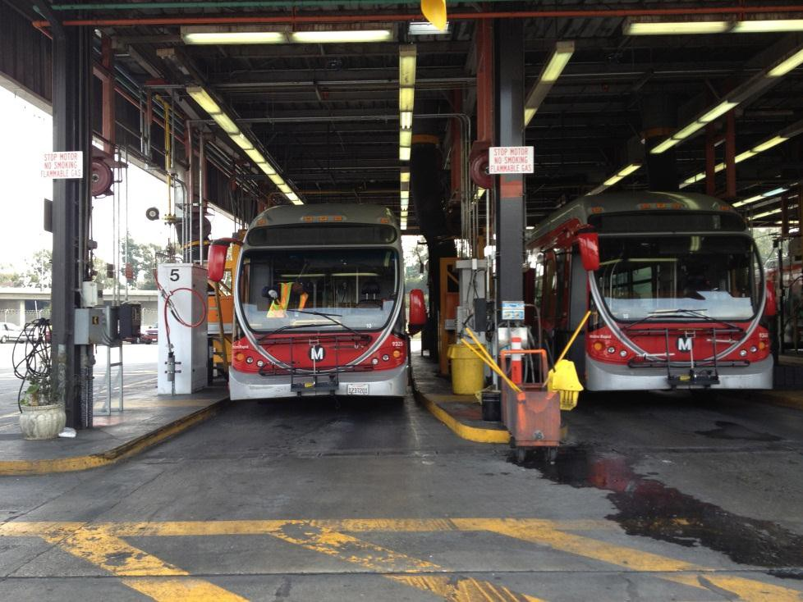

[richard.laver@ch2m.com](mailto:richard.laver@ch2m.com)

**Dan Schriever**

Booz Allen Hamilton

703-677-8424

[schriever_dan@bah.com](mailto:schriever_dan@bah.com)

# Appendix A - Useful Constrained Expenditure Scenarios

|  |  |  |
| --- | --- | --- |
| **Scenario** | **Purpose / Value** | **How to Define** |
| Maintain | * What is the impact on the SGR backlog and | * Enter $0 for year 0 |
| Current | prioritization of continuing to reinvest at the | * For years 1 to 20 enter avg. level of Service Board |
| Spending | current (historical) rate? | reinvestment for past 5 to 10 years |
|  |  | * Can adjust for inflation |
| Maintain | * What level of investment will maintain the | * User must enter test values for years 1 to 20 (enter |
| Backlog | current size of the backlog (either in dollar | same value for each year) and run the model |
|  | terms or as a percent of all asset holdings)? | multiple times until value of backlog in year 20 = |
|  |  | value in year 0. |
| SGR in 20 | * What level of annual reinvestment is required | * User must enter test values for years 1 to 20 (e.g., |
| Years | to eliminate the SGR backlog in 20 years? | enter same value for each year) and run the model |
|  |  | multiple times until value of SGR backlog = $0 in |
|  |  | year 20. |
| Un-constrained | * What would avg. annual reinvestment be if | * Enter a very high level of investment (e.g., $500B) |
|  | there was no backlog? | for years 0 (backlog year) through year 20 |
|  | * Investment must be higher than this to reduce |  |
|  | the backlog |  |

Enter year by year funding amounts that are both (1) financially sustainable and (2) correspond with timing of known major reinvestment needs

* Output will show impact of plan on future SGR backlog and help prioritize needs

•

“Planned” or “Budgeted”

Appendix B - How to Define a Scenario

**Scenario Control**

**(Location)**

**Description & Use Example Uses**

* Sample scenarios include:
  + Unconstrained needs
  + Maintain current spending
  + Level of funding to attain SGR
* User controls level of expenditures for projection years 0 through 30
* Used to assess impact of varying rates of reinvestment on conditions, prioritization and the SGR backlog

Expenditure Constraints (Scenario Settings Form)

Prioritization Settings (Scenario Settings Form)

* While typically held fixed, user can change investment scoring to assess impact on priority rankings, composition of reinvestment activities, and SGR backlog
* User can alter:
  + Criteria weights (simple adjustment)
  + Fixed criteria scoring (detailed change)
* User can select:
  + Current year dollars – in Start Year dollars as input on Main Menu
  + Year of Expenditure – based on user entered rate
* Sets assumed rate of inflation for analysis period from year 0 to 30 – same rate applied across all years
* “Sensitivity” factor allows user to simultaneously adjust all projection costs up or down by the same set amount (default value is 100%)

Inflation

(Input Data Form)

# Appendix B - How to Define a Scenario

**Scenario Control (Location)**

**Description & Use Example Uses**

* e.g., change the useful life of “twelve year) buses to 14 years
* User can alter the useful life values of individual assets
* Extending asset useful lives will lower long-term needs as assets require less frequent replacement

Asset Useful Life

(Asset Inventory Update Tab: Input Data Form)

Override

(Asset Inventory Update Tab: Input Data Form)

* Assign one of four levels of priority
  + Funded (highest priority)
  + Deficient
  + Normal
  + Exclude (from analysis)
* These settings only emphasize certain assets of another. However, each scenario is still subject to the maximum annual funding available.
* User can assess impact on needs of increasing/reducing number and/or cost of rehabs (note: will not impact condition measures)
* User can alter number, timing and cost of rehabs
* Also controls cost of annual capital maintenance

Life Cycle Costs (Input Data Form)

Useful Life Factor (Main Menu)

* When set to values other than 100%, assets will be kept in service longer or shorter than their expected useful lives
* This single factor allies to all assets
* Note: Useful life values are not altered (hence, if factor is set to 110%, assets will be kept in service until 110% of their expected useful life but will be overage one they exceed 100% of useful life)

# Appendix C – Reports

|  |  |  |
| --- | --- | --- |
| **Report** | **Type** | **Content** |
| Asset Inventory Record Ages | * Input Data | * Analysis of the age of the tools’ asset records |
| Asset Inventory Replacement Value | * Inventory | * Total replacement value of all * Grouped by mode and asset category |
| Asset Types | * Input Data | * Asset types recognized by the database * Data tab provides detail on asset life-cycle cost assumptions |
| Average Annual Expenditures | * Needs | * Average annual level of dollar investment needs over 20-years |
| Forecast | forecast | of model run (based on scenario inputs) |
| Condition Distribution Forecast | * Condition | * Forecast of percent of assets in excellent, good, fair, marginal and poor condition |
| Expenditures Forecast | * Needs forecast | * Forecast of prioritized annual investment needs (based on scenario inputs) |

Appendix C – Reports

|  |  |  |
| --- | --- | --- |
| **Report** | **Type** | **Content** |
| Over Age Asset Forecast | * Condition | * Forecast of percent of assets that exceed their useful life (based on scenario inputs) |
| Priority Scores: Backlog Investments | * Prioritization | * Record level prioritization scores for investments to reduce |
| by Asset Record (Detail) | scores | current backlog (year 0) |
| Priority Scores: Backlog Investments | * Prioritization | * Prioritization scores for investments to reduce current backlog |
| by Asset Type by Location | scores | (year 0) grouped by asset type and location |
| Priority Scores: Backlog Investment | * Prioritization | * Prioritization scores for investments to reduce current backlog |
| by Asset Type (Base 100) | scores | (year 0) grouped only by asset type |
| Priority Scores: Summary Scores By | * Prioritization | * Prioritization scores grouped only by asset type for projection |
| Asset Type for Next 10 Years | scores | years 0 to 20 |
| SGR Backlog Forecast | * Backlog | * Projection of SGR backlog for years 0 through 20 (based on scenario inputs) |

Appendix D – Field Definitions

Optional asset identifier

number

|  |  |  |  |  |  |
| --- | --- | --- | --- | --- | --- |
| **Field Name** | **Description** | **Required**  **Field?** | **Notes** | **Data**  **Type** | **Text Field**  **Size** |
| **Asset ID** | Unique Asset ID | No |  | Integer |  |
| **Agency ID**  **Code** | Agency ID Code | Yes | Use "9999" for default value | Text | 25 |
| **Transit System** | Agency Name | Recomme  nded |  | Text | 50 |
| **Mode Code** | NTD mode code | Yes | Two (2) letter FTA transit mode codes: CR, HR, LR, MB, DR,  BRT, VP | Text | 25 |
| **Description** | Agency specified asset type name | No | Asset Description | Text | 50 |
| **Asset Type Code** | TERM Asset Type Code (5 digit code) | Yes | Must be selected from asset  type codes populated in tbl05AssetTypes (5 digit code) | Integer |  |
| **Category** | TERM Asset Category | Yes |  | Text | 50 |
| **Sub-Category** | TERM Asset Sub-category | Yes |  | Text | 50 |
| **Element** | TERM Asset Element | Yes |  | Text | 50 |
| **Sub-Element** | TERM Asset Sub-element | Yes |  | Text | 50 |
| **Quantity** | Unit quantity | Yes | Can be entered as decimal  value | Double |  |
| **Units** | Type of units (e.g., each, sq feet,  miles, spaces) | Recomme  nded |  | Text | 25 |

Appendix D – Field Definitions

Enter four digit value for year

“XXXX”

|  |  |  |  |  |  |
| --- | --- | --- | --- | --- | --- |
| **Field Name** | **Description** | **Required**  **Field?** | **Notes** | **Data**  **Type** | **Text Field**  **Size** |
| **Date Built** | Year asset was built / entered  service life | Yes |  | Integer |  |
| **Rehabed** | Has asset been rehabbed: False or True | Yes | Indicate yes if asset has  undergone significant rehab investments | True/Fa lse |  |
| **CostYr** | Dollar year replacement costs are  denominated in | Yes | e.g., $2012; Enter four digit  value for cost year “XXXX” | Integer |  |
| **Agency_SoftC**  **ost** | Assumed soft-cost factor | Yes | Will be added to rehab and  replacement cost calculations | Percent |  |
| **Unit Replacement**  **Cost** | Unit replacement cost denominated in "CostYr" dollars | Yes | Enter full value, including cents if needed (e.g., $X,XXX.XX) | Double |  |
| **Current**  **Dollars Total Cost** | Total replacement cost denominated in "CostYr" dollars | No | Tool will auto-populate this field  when model is run based on unit cost and unit quantity | Double |  |
| **Total Replacement**  **Cost** | Total replacement cost denominated in model start year  dollars | No | Tool will auto-populate this field when model is run based on  unit cost and unit quantity | Double |  |

Appendix D – Field Definitions

|  |  |  |  |  |  |
| --- | --- | --- | --- | --- | --- |
| **Field Name** | **Description** | **Required**  **Field?** | **Notes** | **Data**  **Type** | **Text Field**  **Size** |
| **PriorityStatus** | Assigns assets to one of four levels  of priority stauts: Funded,  Deficient, Normal, Exclude | Recomm  ended | Default value is "Normal": Funded and Deficient forces highly prioritized asset replacement (or highest priority for replacement). Assets with Exclude selected will not be  included in needs analysis. | True/Fa  lse |  |
| **Condition**  **Rating** | Observed, actual condition rating  for asset | No | Informational only / will be used  in future | Double |  |
| **Data Date** | Date the asset record was last  updated | Recomm  ended |  | Integer |  |
| **Data Source** | Source of asset data | Recomm  ended |  | Text | 50 |
| **Agency_Usefu lLife** | Expected useful life of asset in years (e.g., “50”) | Highly Recomm  ended | Tool will utilize default useful life value from asset types table if  not populated | Integer |  |
| **Notes** | Additional details on asset (type,  history, special considerations) | No |  | Text | 255 |

Appendix D – Field Definitions

|  |  |  |  |  |  |
| --- | --- | --- | --- | --- | --- |
| **Field Name** | **Description** | **Required**  **Field?** | **Notes** | **Data**  **Type** | **Text Field**  **Size** |
| **DelayReplaceAge** | Allows user to specify an asset replacement age in years that differs from Useful life (e.g.,  “55”) | No | Useful for forced scheduling of asset replacement (e.g., based on planned procurement) | Integer |  |
| **Existing_Expansio n** | Enter “Existing” for assets currently in service / “Expansion” for (non- replacement) assets to be  acquired in a future year | No | Date built values for expansion assets occur in the future | Text | 50 |
| **Start_Year** | Start year for model run (temporary field that will be  removed) entered as “XXXX” | Yes | Please enter expected start year of analysis (this field to be  eliminated) entered as “XXXX” | Integer |  |
| **Agency_Asset_Ty**  **pe** | Optional: User defined asset  type | No |  | Text | 50 |
| **Make_Model** | Optional: Asset make/model | No |  | Text | 50 |
| **Agency_Asset_ID** | Optional: User defined asset  ID # | No |  | Text | 50 |

Appendix D – Field Definitions

Used to group related agency asset IDs to a parent number. Example would be to group individual agency asset IDs for components of a maintenance facility (roof, HVAC, etc.) to a common parent ID. Recommended to populate with asset ID if there is no parent ID (to support grouping at Parent

ID level)

|  |  |  |  |  |  |
| --- | --- | --- | --- | --- | --- |
| **Field Name** | **Description** | **Required**  **Field?** | **Notes** | **Data**  **Type** | **Text Field**  **Size** |
| **Agency_Asset_Par ent_ID** | Optional: User defined parent asset ID # | No |  | Text | 50 |
| **Line_Division** | Optional: Rail line or bus  division | No |  | Text | 50 |
| **Branch_Garage** | Optional: Rail branch or bus  garage | No |  | Text | 50 |
| **Segment_Route** | Optional: Rail segment or bus  route | No |  | Text | 50 |
| **Start** | Optional: Mile post marker  start | No |  | Text | 50 |
| **End** | Optional: Mile post marker end | No |  | Text | 50 |

Appendix D – Field Definitions

|  |  |  |  |  |  |
| --- | --- | --- | --- | --- | --- |
| **Field Name** | **Description** | **Required**  **Field?** | **Notes** | **Data**  **Type** | **Text Field**  **Size** |
| **Latitude** | Optional: Asset location  latitude | No |  | Text | 50 |
| **Longitude** | Optional: Asset location  longitude | No |  | Text | 50 |
| **Address** | Optional: Asset street address | No |  | Text | 255 |
| **UserField1** | Optional: User defined field  (open to user to determine field contents) | No |  | Text | 100 |
| **UserField2** | Optional: User defined field (open to user to determine  field contents) | No |  | Text | 100 |
| **UserField3** | Optional: User defined field (open to user to determine  field contents) | No |  | Text | 100 |
| **UserField4** | Optional: User defined field (open to user to determine  field contents) | No |  | Text | 100 |
| **Dept_Asset_Owne r** | Optional: Identifies which  agency department is responsible for the asset | No |  | Text | 50 |

Appendix D – Field Definitions

E.g., various segments of trackwork might be grouped

together into a single project

|  |  |  |  |  |  |
| --- | --- | --- | --- | --- | --- |
| **Field Name** | **Description** | **Required**  **Field?** | **Notes** | **Data**  **Type** | **Text Field**  **Size** |
| **Agency_Project_N umber** | Optional: Identifies project number asset would be  grouped with for reinvestment | No |  | Text | 30 |
| **Agency_Project_C ategory** | Optional: Identifies type or name assets with same Agency_Project_Number would be grouped with for  reinvestment | No | E.g., various types of trackwork might be grouped together into a single project type | Text | 150 |
| **Agency_project_D esc** | Optional: Provides project or asset specific description for assets grouped with same  Agency_Project_Number | No |  | Text | 100 |